Exercise on Mutation Testing
Week 5: Mutation Testing

Setup the project:
- Install Maven. Search Youtube for guides in your preferred OS.
  - Make sure your environmental variables are defined.
  - Run mvn -v on your terminal to see that Maven is working.
- Download and unzip “QAT_Week5_Exercise_Mutation” from Canvas.
- Import the Java project to your IDE (e.g., Visual Studio Code)

Part 1: Understanding the Code and Designing Tests

- The diagram below shows the different classes and their relationships
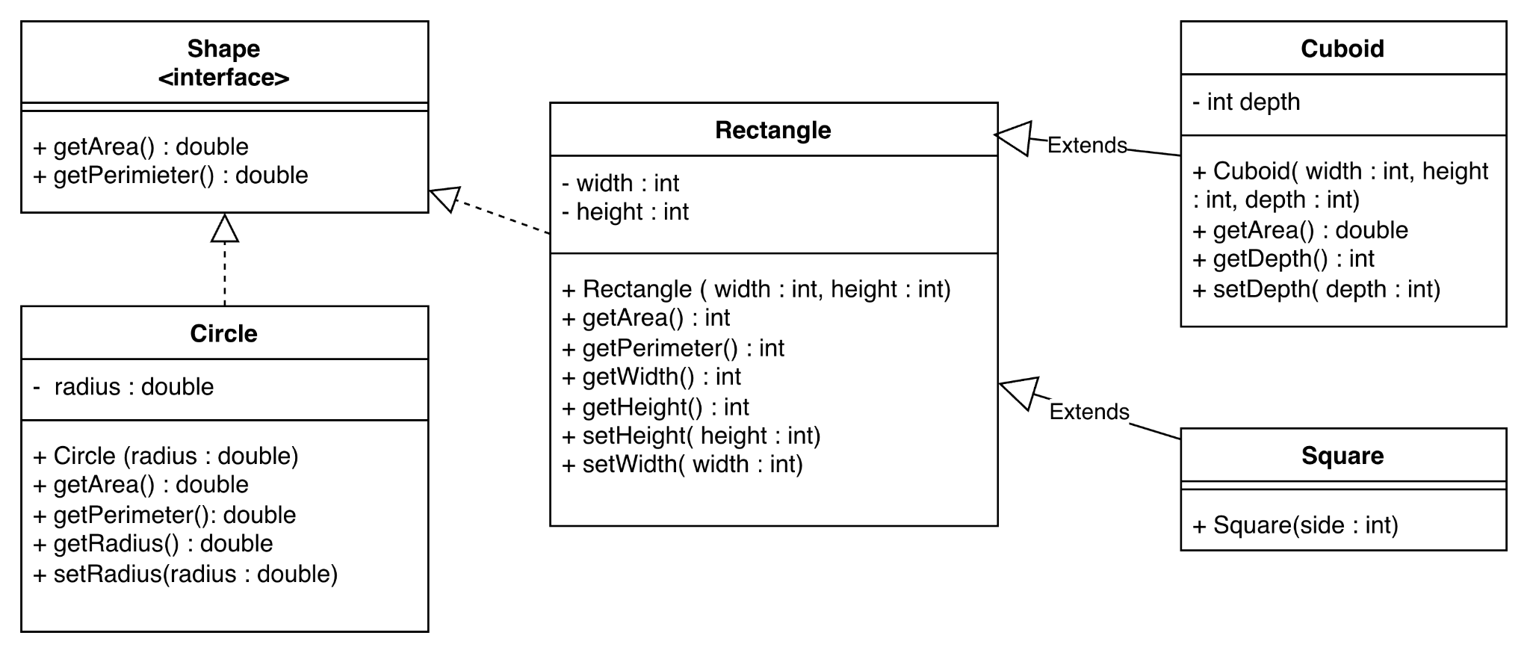

- Generate 10 test cases for the classes below.

- Manually create 10 mutants and add them to the table below:

ID | Mutation Operator | Class | LoC | Mutant
M1
M2
M3
M4
M5
M6
M7
M8
M9
M10

- Run your test cases against the mutants. Fill in the mutation matrix and calculate the mutation score.

 | M1 | M2 | M3 | M4 | M5 | M6 | M7 | M8 | M9 | M10
T1
T2
T3
T4
T5 | x
T6
T7
T8
T9
T10

- Write down your reflections on the points below:
  - Did you use a variety of operators? Were some harder/easier to apply than others?
  - Was there a type of mutant that was harder / easier to kill?
  - Was there a test case that is very good at killing multiple mutants?

Part 2: Automating Mutation Testing with PIT
- PIT should be configured in your project’s pom.xml file.
- In the terminal (project root), run the command (https://pitest.org/quickstart/maven/):

mvn test-compile org.pitest:pitest-maven:mutationCoverage

- Check the mutation report in folder: target > pit-reports > index.html

Reflect on the questions:

- How similar / different were your code and mutation coverage across different classes?
- Was there a mutation operator from PIT that was harder to kill?
- Repeat the steps in Part 1 to create new tests to kill the surviving mutants.

